

Installation Guide

PROJECT NAME: National Level Paper Presentation
Group: 3 Batch: GC0862

A. System Requirement:
Sr. | Item | Description
1. | OS | [Windows 7 or higher]
2. | Database | [SQL Server 2008 or higher]
3. | Web Server | [Jboss 5.x or higher]
4. | Web Browser | [Firefox 28.0 or higher]
5. | Fonts | Arial, Tahoma, Lucida Console, Times New Roman..Etc.…
6. | Runtime Environment | Java SE Development Kit 6 (JDK 1.6)
7. | Screen Resolution | 1024x768

B. Program Installation Guide

- Step 1: Unarchive zip file name eProject on your mail. Copy eProject to D:\
- Step 2: Configuration SQL, modify sa login account and create database

- Modify an Account login in SQL Server 2008
  - Start → Programs → Microsoft SQL Server 2008 → SQL Server Management Studio
You login by account of SQL Server Authentication (sa

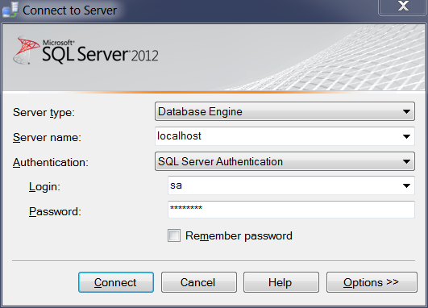

  - In windows Object Explorer → Security/Login → sa → Properties

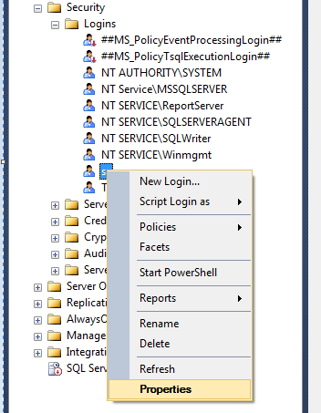

  - On windows Login Properties – sa
  - Click on SQL Server authentication you input password into Password and Confirm Password
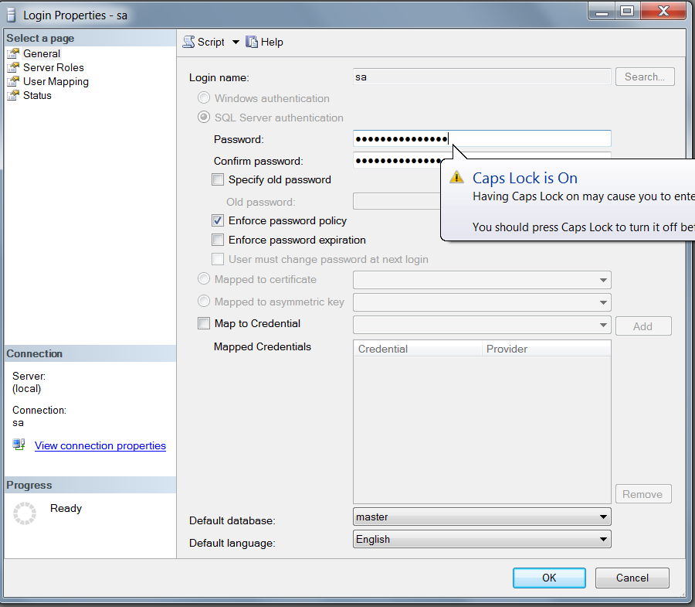
  - Password input: 12345678
  - Then you click button OK
  - Restart SQL Server Management Studio
- Create Database :
  - File → Open → File…



  - Browse to file named kscUniversityDB.sql in eProject/deploy – install/Database Folder.
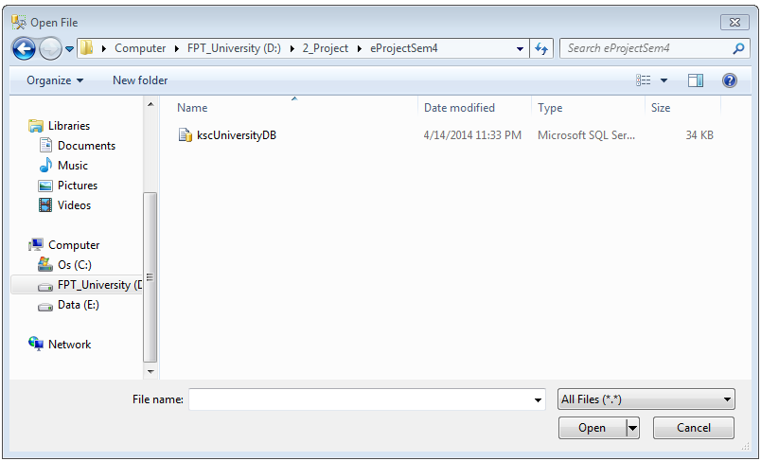
  - Open.
  - Select All Script.
  - Query →Execute
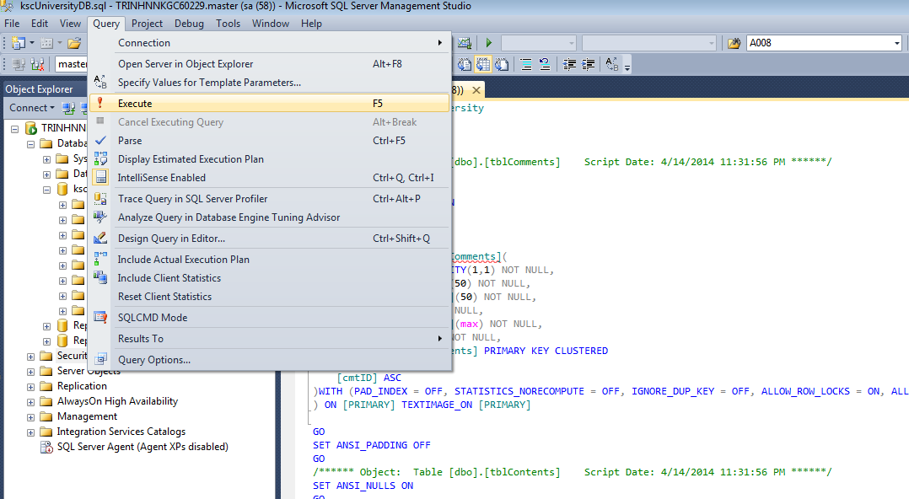
- If Success we’ll have a database like this:

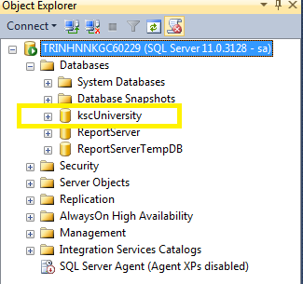

Install Website:
Step 1: Rename file ePJNational.ear into ePJNational.zip from folder ePJNational at ePJNational \deploy – install\
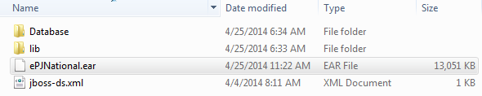
Step 2: Unzip file ePJNational.zip and we will see 3 files 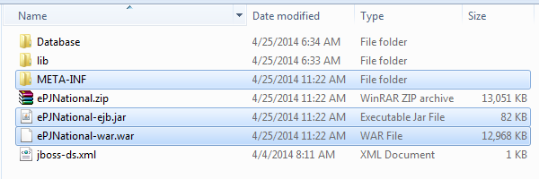
Step 3: Rename file ePJNational -war.war into ePJNational -war.zip from folder ePJNational \deploy – install\ like step 1. 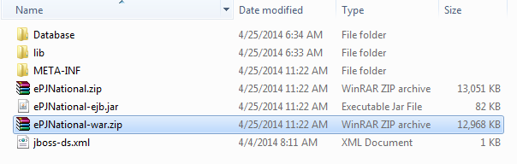

Step 4: Unzip file ePJNational - war.zip to folder with the same name.
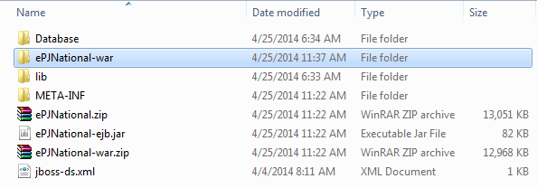

Step 5: Rename folder ePJNational -war into ePJNational-war.war 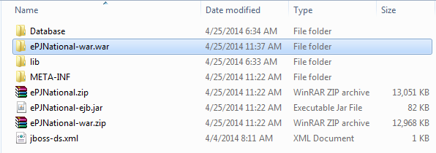
Step 6: Copy all file from folder ePJNational \deploy – install\ lib into folder jboss-5.1.0.GA\server\default\lib
Step 7: Copy file ePJNational \deploy – install\ ePJNational-ejb.jar into folder jboss- 5.1.0.GA\server\default\deploy
Step 8: Copy folder ePJNational \deploy – install\ ePJNational-war.war into folder jboss-5.1.0.GA\server\default\deploy

Step 9: Copy file jboss-ds.xml from folder ePJNational \deploy – install\ into folder jboss-5.1.0.GA\server\default\deploy. If username and password to login SQL isn’t same sa and 12345678. You need to change follow the picture below. 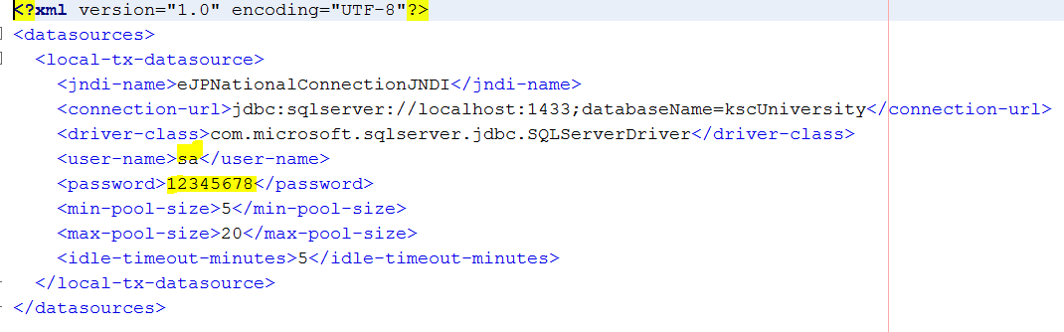

C. Signs install success
Step 1: Run file run.bat from folder jboss-5.1.0.GA\bin
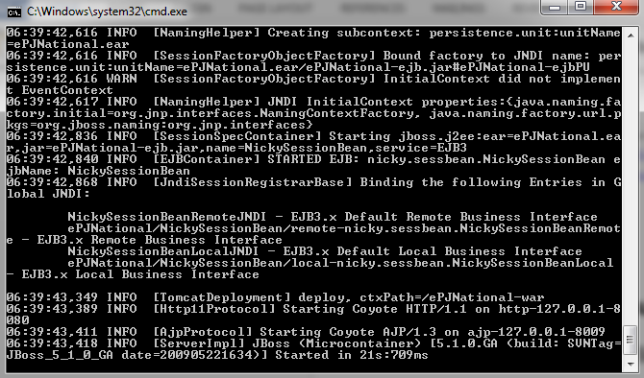
Start sever success
Step 1.1 : If Server is not running.
Step 1.2 : Open Advanced System Settings in Control Panel\All Control Panel Items\System.
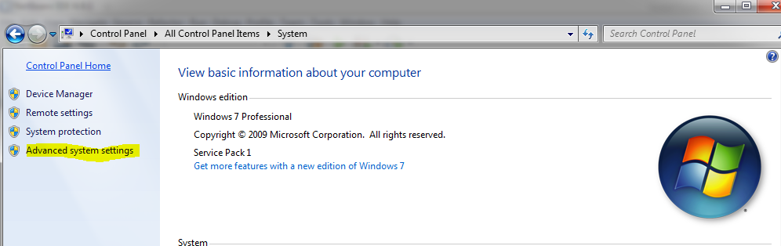

Step 1.3 : In Advanced tab , Click on Environment Variables
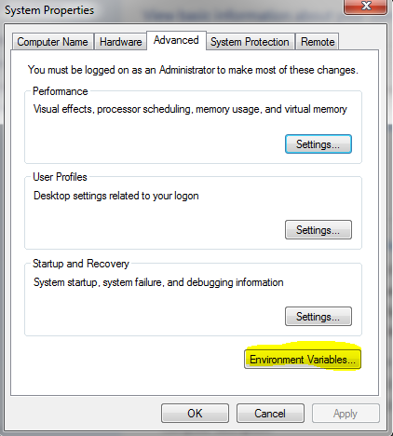
Step 1.4 : In System Variables , look for variables that named : JAVA_HOME and JBOSS_HOME.
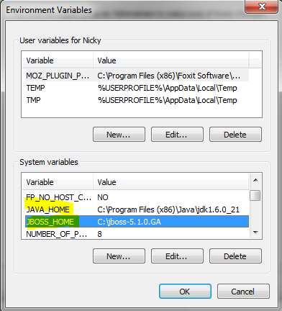
Step 1.5 : If those variables are not existed . Press on New to create ones.
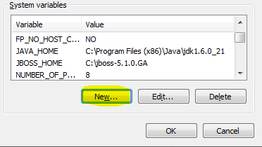
Step 1.6 : Type JBOSS_HOME in “Variable Name” box and then the location to Jboss Server in “Variable value” box.Click OK.
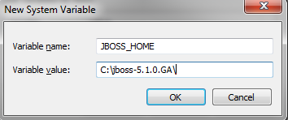
Step 1.7 : Click on New button just like in step 1.5. Type JAVA_HOME in “Variable Name” box and then the location to JAVA JDK in “Variable value” box.Click OK.
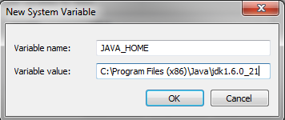
Step 1.8 : Try again to start jboss server like in step 1 .Server should run successfully . If not, try to restart your system and try again.

Step 2: At address bar on Firefox, type :
http:// localhost:8080/ePJNational-war/ and press enter

Website display success

